**EL 연습**

I.

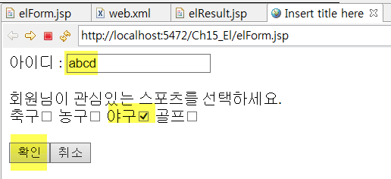 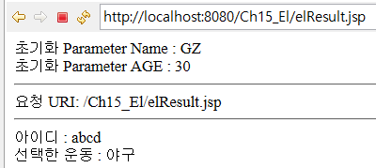

[elForm.jsp]

|  |
| --- |
| <%@ page language=*"java"* contentType=*"text/html; charset=UTF-8"*  pageEncoding=*"UTF-8"*%>  <!DOCTYPE html>  <html>  <head>  <meta *charset="UTF-8"*>  <title>Insert title here</title>  </head>  <body>    </body>  </html> |

[web.xml]

|  |
| --- |
| <?xml version=*"1.0"* encoding=*"UTF-8"*?>  <web-app xmlns:xsi=*"http://www.w3.org/2001/XMLSchema-instance"* xmlns=*"http://java.sun.com/xml/ns/javaee"* xsi:schemaLocation=*"http://java.sun.com/xml/ns/javaee http://java.sun.com/xml/ns/javaee/web-app_3_0.xsd"* id=*"WebApp_ID"* version=*"3.0"*>  <display-name>Ch11_EL</display-name>  </web-app> |

[elResult.jsp]

|  |
| --- |
| <%@ page language=*"java"* contentType=*"text/html; charset=UTF-8"* pageEncoding=*"UTF-8"*%>  <% request.setCharacterEncoding("UTF-8"); %>  <% request.setAttribute("name","이순신"); %>  <!DOCTYPE html>  <html>  <head>  <meta *charset="UTF-8"*>  <title>표현언어</title>  </head>  <body>  </body>  </html> |

2. EL 표기법을 사용하여 JavaBeans의 Property 값을 출력하기

[결과]

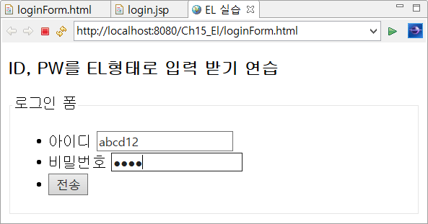

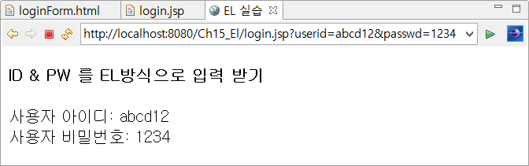

[방법]

1. LoginBean 클래스 생성

|  |
| --- |
| **package** com.bean;  **import** java.io.Serializable;  **public** **class** LoginBean **implements** Serializable {  **private** **static** **final** **long** ***serialVersionUID*** = 1L;  **private** String userid;  **private** String passwd;  **public** LoginBean() {  **super**();  }  **public** String getUserid() {  **return** userid;  }  **public** **void** setUserid(String userid) {  **this**.userid = userid;  }  **public** String getPasswd() {  **return** passwd;  }  **public** **void** setPasswd(String passwd) {  **this**.passwd = passwd;  }  } |

2. loginForm.html 작성

|  |
| --- |
| <!DOCTYPE html>  <html>  <head>  <meta charset=*"UTF-8"*>  <title>EL 실습</title>  </head>  <body>  <h3>ID, PW를 EL형태로 입력 받기 연습</h3>  </body>  </html> |

3. login.jsp

EL표기법을 사용하여 LoginBean에 저장된 property 값을 출력한다(useBean

|  |
| --- |
| <%@ page language=*"java"* contentType=*"text/html; charset=UTF-8"*  pageEncoding=*"utf-8"*%> |